**Program 18:**

Create an HTML page to demonstrate all types of CSS position properties (static, relative, absolute, fixed, and sticky).

**HTML Code:**

<!DOCTYPE *html*>

<html *lang*="en">

<head>

    <meta *charset*="UTF-8">

    <meta *name*="viewport" *content*="width=device-width, initial-scale=1.0">

    <title>CSS Position Properties</title>

    <style>

        body {

            border: 5px solid black;

            margin: 20px;

            padding: 20px;

            font-family: Arial, sans-serif;

        }

*.static* {

            position: static;

            background-color: lightblue;

            padding: 10px;

            margin-bottom: 10px;

        }

*.relative* {

            position: relative;

            top: 20px;

            left: 20px;

            background-color: lightgreen;

            padding: 10px;

            margin-bottom: 10px;

        }

*.absolute-container* {

            position: relative;

            height: 200px;

            background-color: lightgray;

            margin-bottom: 10px;

        }

*.absolute* {

            position: absolute;

            top: 50px;

            left: 50px;

            background-color: lightcoral;

            padding: 10px;

        }

*.fixed* {

            position: fixed;

            top: 10px;

            right: 10px;

            background-color: lightgoldenrodyellow;

            padding: 10px;

        }

*.sticky* {

            position: sticky;

            top: 0;

            background-color: lightpink;

            padding: 10px;

            margin-bottom: 10px;

        }

    </style>

</head>

<body>

    <h1>CSS Position Properties</h1>

    <div *class*="sticky">This is a sticky positioned element. Scroll down to see the effect.</div>

    <p>Duis aute irure dolor in reprehenderit in voluptate velit esse cillum dolore eu fugiat nulla pariatur.</p>

    <p>Duis aute irure dolor in reprehenderit in voluptate velit esse cillum dolore eu fugiat nulla pariatur.</p>

    <p>Duis aute irure dolor in reprehenderit in voluptate velit esse cillum dolore eu fugiat nulla pariatur.</p>

    <p>Duis aute irure dolor in reprehenderit in voluptate velit esse cillum dolore eu fugiat nulla pariatur.</p>

    <p>Duis aute irure dolor in reprehenderit in voluptate velit esse cillum dolore eu fugiat nulla pariatur.</p>

    <p>Duis aute irure dolor in reprehenderit in voluptate velit esse cillum dolore eu fugiat nulla pariatur.</p>

    <div *class*="static">This is a static positioned element (default).</div>

    <div *class*="relative">This is a relative positioned element.</div>

    <div *class*="absolute-container">

        <div *class*="absolute">This is an absolute positioned element.</div>

    </div>

    <p>Lorem ipsum dolor sit amet, consectetur adipiscing elit. Sed do eiusmod tempor incididunt ut labore et dolore magna aliqua.</p>

    <p>Ut enim ad minim veniam, quis nostrud exercitation ullamco laboris nisi ut aliquip ex ea commodo consequat.</p>

    <p>Duis aute irure dolor in reprehenderit in voluptate velit esse cillum dolore eu fugiat nulla pariatur.</p>

    <p>Excepteur sint occaecat cupidatat non proident, sunt in culpa qui officia deserunt mollit anim id est laborum.</p>

    <div *class*="fixed">This is a fixed positioned element.</div>

    <pre>Name: Priyanshu Thapliyal   Std.Id: 220112794   Sem: 6th   Sec: C1</pre>

</body></html>

**Output:**

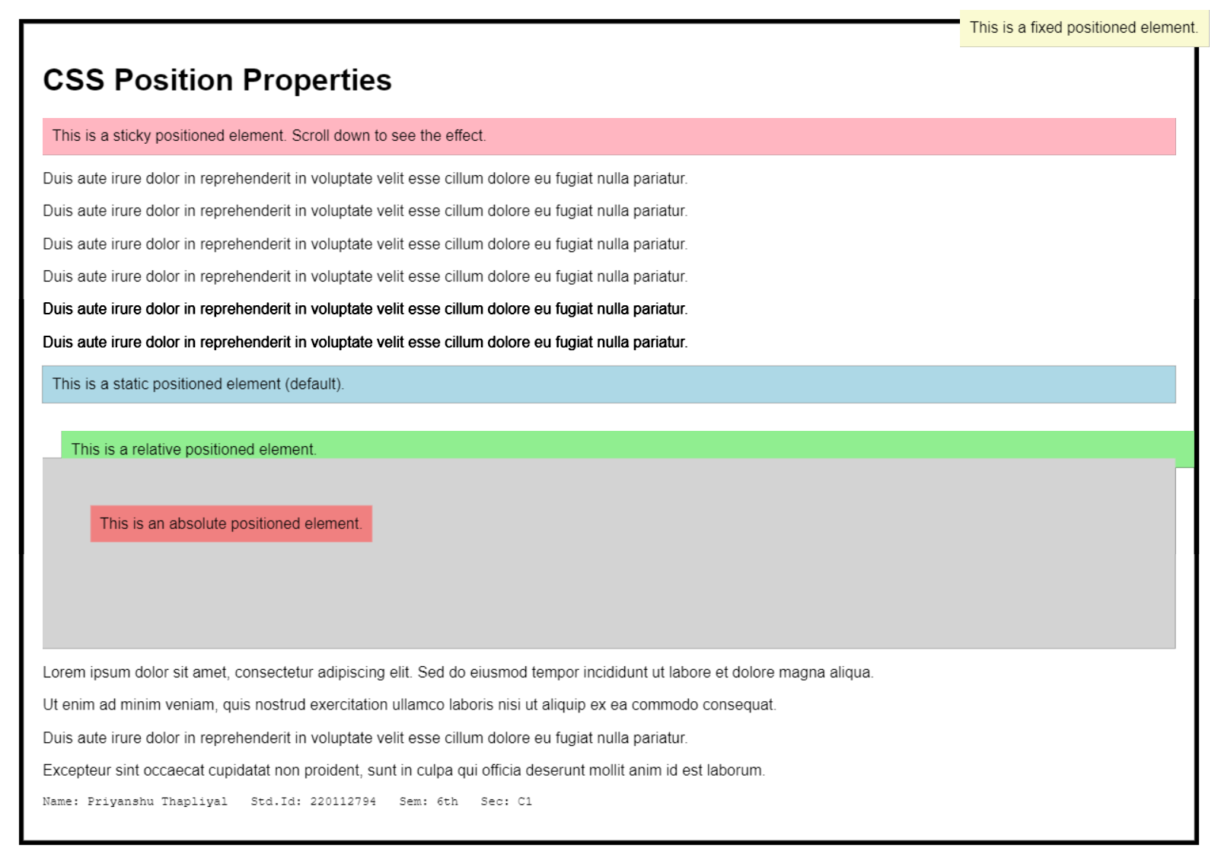

**Program 19:**

Design a web page using CSS which includes the following:

1. Use different font styles
2. Set background image for both the page and single elements on page.
3. Control the repetition of image with background-repeat property
4. Define style for links as a:link, a:active, a:hover, a:visited
5. Add customized cursors for links.
6. Work with layers.

**HTML Code:**

<!DOCTYPE *html*>

<html *lang*="en">

<head>

    <meta *charset*="UTF-8">

    <meta *name*="viewport" *content*="width=device-width, initial-scale=1.0">

    <title>Web Page using CSS</title>

    <style>

        body {

            border: 5px solid black;

            padding: 20px;

            margin: 20px;

            font-family: Arial, sans-serif;

            background: url('repeat.jpg') no-repeat center center fixed;

            background-size: cover;

        }

*.header* {

            text-align: center;

            font-size: 24px;

            font-weight: bold;

            margin-top: 10px;

        }

        a {

            color: blue;

            text-decoration: none;

            font-weight: bold;

        }

        a*:hover* {

            color: red;

            text-decoration: underline;

            cursor: pointer;

        }

        a*:visited* {

            color: purple;

        }

        a*:active* {

            color: green;

        }

*.image-container* {

            width: 300px;

            height: 200px;

            background: url('img.webp') no-repeat center;

            background-size: cover;

            margin: 20px auto;

        }

*.layer* {

            font-size: 30px;

            font-weight: bold;

            position: absolute;

        }

*.layer1* {

            top: 300px;

            left: 50%;

            color: red;

            width: 220px;

            font-size: 50px;

            height: 100px;

            transform: translateX(-50%);

            z-index: 1;

        }

*.layer2* {

            top: 330px;

            left: 50%;

            color: blue;

            transform: translateX(-50%);

            z-index: 2;

        }

*.layer_a* {

            font-size: 30px;

            font-weight: bold;

            position: absolute;

        }

*.layer3* {

            top: 400px;

            left: 50%;

            color: red;

            width: 220px;

            font-size: 50px;

            height: 100px;

            z-index: 2;

        }

*.layer4* {

            top: 430px;

            left: 50%;

            color: blue;

            z-index: 1;

        }

    </style>

</head>

<body>

    <div *class*="header">

        <h1>Web Page using CSS</h1>

    </div>

    <div>

        Welcome to this page using CSS! We are applying different fonts, background styles, and layers.

    </div>

    <div *class*="content">

        <p><a *href*="#">Register</a></p>

        <div *class*="image-container"></div>

    </div>

    <div *class*="layer layer1">LAYER 1</div>

    <div *class*="layer layer2">LAYER 2</div>

    <div *class*="layer_a layer3">LAYER 2</div>

    <div *class*="layer_a layer4">LAYER 1</div>

    <pre>Name: Priyanshu Thapliyal Std.Id: 220112794 Sem: 6th Sec: C1</pre>

</body>

</html>

**Output:**

